

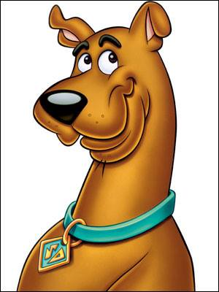

**Scooby Doo**

Hello, my name is Scooby Doo. I was raised in Cartoon Land where I graduated with high honors from Highland High School in 2009. I went on to graduate magna cum laude with a Bachelor’s degree in Exercise Physiology from BYU-Idaho in 2015.

After my first semester of college. I have had the opportunity to keep up on the language during employment as a landscaper as well as a Physical Therapy Technician. In the physical therapy clinic, I was responsible for ensuring Spanish speaking patients understood their treatment, which gave me an increased desire to continue to reach out to the Spanish speaking community as a PA. I am excited to further my knowledge of medicine as well as to be an asset to the physicians and patients during my rotations.

In my spare time, I enjoy spending time with my wife in the outdoors, whether it is hiking, camping, skiing, or dirt biking. I was fortunate to find a beautiful girl who enjoys these things just as much as I do.